PROJECT REPORT
Project Detail | Value
Project Name | Employee Issue Management
Name | Vatsavai Venkatasai Devavarshita
Project Date | 17 September 2026

1. PROJECT DESIGN

1.1 Problem Solution Fit

The solution directly maps the identified employee issue-management problems to ServiceNow capabilities. The Service Portal provides a standardized entry point, the Record Producer captures structured issue information, the custom Employee Issue table provides a persistent record, validation and field dependencies improve data quality, Business Rules support server-side processing, and assignment, prioritization, and status tracking provide a structured issue lifecycle.

Problem Area | ServiceNow Solution | Expected Effect
Unstructured employee issue reporting | Service Portal with Raise an Employee Issue Record Producer | Consistent and standardized issue submission.
Incomplete or invalid information | Client Scripts, UI Policies, and Data Policies | Improved data quality and controlled form submission.
Dependent or irrelevant form fields | Field Dependencies and UI Policies | Dynamic and relevant form behavior.
Issues not centrally recorded | Employee Issue Custom Table | Centralized and persistent issue records.
Manual server-side processing | Business Rules | Consistent automated processing of submitted issues.
Issues not routed to the appropriate team | Assignment Logic / Assignment Group | Structured issue routing to the responsible support team.
Inconsistent issue prioritization | Priority Logic | More consistent handling based on configured issue information.
Limited visibility of issue progress | Issue Status and Resolution Tracking | Clear tracking from submission through resolution.
Informal communication and manual coordination | Centralized ServiceNow issue records | Reduced communication overhead and improved traceability.
Limited lifecycle traceability | Employee Issue record with related processing information | Single trackable record for the employee issue lifecycle.

1.2 Proposed Solution

The proposed process starts when an employee accesses the Service Portal and selects Raise an Employee Issue. The employee enters the required issue information such as issue category, description, and other relevant details. The Record Producer validates the submitted information and creates an Employee Issue record in the custom table. Configured Client Scripts, UI Policies, Data Policies, and field dependencies control the form behavior and ensure consistent data entry.

After submission, server-side Business Rules process the Employee Issue record and apply the configured categorization, assignment, and prioritization logic. The issue is then routed to the appropriate support or assignment group for handling. The support team updates the issue status as work progresses until the issue is resolved and the resolution information is recorded.

Core lifecycle: Service Portal → Raise an Employee Issue → Record Producer → Validation & Field Dependencies → Employee Issue Custom Table → Business Rules → Assignment & Prioritization → Issue Handling → Status Updates → Resolution → Tracking.

1.3 Solution Architecture
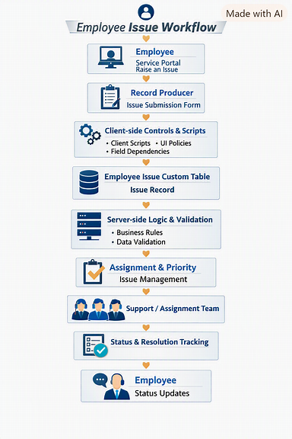
Layer | Components | Responsibility
User Layer | Employee / Service Portal User | Accesses the Service Portal and initiates an employee issue.
Submission Layer | Service Portal / Raise an Employee Issue / Record Producer | Provides the employee-facing form and captures issue information.
Validation Layer | Client Scripts / UI Policies / Data Policies / Field Dependencies | Validates input, controls field behavior, and ensures required information is provided.
Data Layer | Employee Issue Custom Table | Stores submitted employee issues and their associated details.
Business Logic Layer | Business Rules / Server-side Processing | Applies server-side validation and processes Employee Issue records.
Assignment & Priority Layer | Assignment Logic / Priority Logic / Assignment Group | Categorizes, prioritizes, and routes issues to the appropriate support team.
Tracking Layer | Issue Status / Resolution Information / Employee Issue Records | Tracks issue progress from submission through handling and resolution.
ServiceNow Platform Layer | ServiceNow Platform / Service Portal Configuration / Developer Tools | Provides the platform services and configuration environment supporting the complete solution.

2. PROJECT PLANNING & SCHEDULING

2.1 Project Planning

Phase | Main Activities | Deliverable
Problem & Ideation | Identify the challenges in informal employee issue reporting and define the proposed ServiceNow solution. | Problem statement and solution concept.
Service Portal Design | Configure the Service Portal entry point and create the Raise an Employee Issue experience. | Employee-facing issue submission interface.
Record Producer & Table Configuration | Create the Record Producer, configure form variables, and create the Employee Issue custom table for storing submitted issues. | Employee Issue Record Producer and custom table.
Validation & Field Behavior | Configure Client Scripts, UI Policies, Data Policies, and field dependencies to validate inputs and control dynamic form behavior. | Validated and structured issue submission form.
Business Logic & Processing | Configure Business Rules for server-side validation and processing of Employee Issue records. | Automated issue-processing logic.
Assignment & Prioritization | Configure issue categorization, assignment-group handling, and priority logic based on issue information. | Assigned and prioritized Employee Issue records.
Issue Tracking | Configure and verify issue status updates from submission through handling and resolution. | Issue lifecycle and status tracking.
Testing | Submit different issue scenarios and verify validation, record creation, Business Rules, assignment, priority, and status progression. | Test results and supporting evidence.
Documentation | Capture screenshots, document configuration and workflow, and prepare the final project report. | Final project report and project documentation.

3. FUNCTIONAL AND PERFORMANCE TESTING

3.1 Performance Testing

The available project evidence primarily demonstrates functional execution of the employee issue management workflow rather than a controlled benchmark of response time, throughput, or concurrent-user capacity. Therefore, no unsupported quantitative performance result is reported. The observed execution was checked for correct submission, record creation, validation, processing, assignment, prioritization, and status progression of Employee Issue records.
Test Case | Input / Action | Expected Result | Observed Evidence | Status
TC-01 | Open Service Portal and select Raise an Employee Issue | Employee issue submission form is displayed. | Raise an Employee Issue form visible in the Service Portal. | Pass
TC-02 | Enter issue category, details, priority-related information, and other required fields | Values are accepted and relevant fields behave according to configured rules. | Employee Issue form displays the entered values and configured field behavior. | Pass
TC-03 | Submit the employee issue | An Employee Issue record is created in the custom table. | Created Employee Issue record is visible in the ServiceNow table. | Pass
TC-04 | Enter incomplete or invalid information | Submission is restricted and appropriate validation is displayed. | Client-side validation prevents incomplete or invalid submission. | Pass
TC-05 | Change a field that controls dependent fields | Related fields/options update according to configured dependencies and UI Policies. | Dependent field behavior is observed on the issue submission form. | Pass
TC-06 | Process the submitted Employee Issue record | Server-side Business Rules execute the configured processing logic. | Employee Issue record reflects the configured server-side processing. | Pass
TC-07 | Apply assignment logic based on issue information | Issue is assigned to the appropriate assignment group/support team. | Assignment group is visible on the Employee Issue record. | Pass
TC-08 | Apply priority logic based on issue information | Issue receives the configured priority. | Priority value is visible on the Employee Issue record. | Pass
TC-09 | Update the issue while it is being handled | Issue status progresses through the configured lifecycle. | Status changes are visible on the Employee Issue record. | Pass
TC-10 | Complete the issue lifecycle and review the record | Issue contains the relevant submission, assignment, priority, status, and resolution information. | Final Employee Issue record reflects the completed management flow. | Pass

Performance Testing Observation:
The above tests confirm functional execution of the implemented ServiceNow workflow. They do not represent a controlled performance benchmark. Response-time, throughput, scalability, and concurrent-user measurements were not collected as part of the demonstrated implementation.

4. RESULTS

4.1 Output Screenshots
The following screenshots were extracted from the project screen recording and are included as implementation evidence.
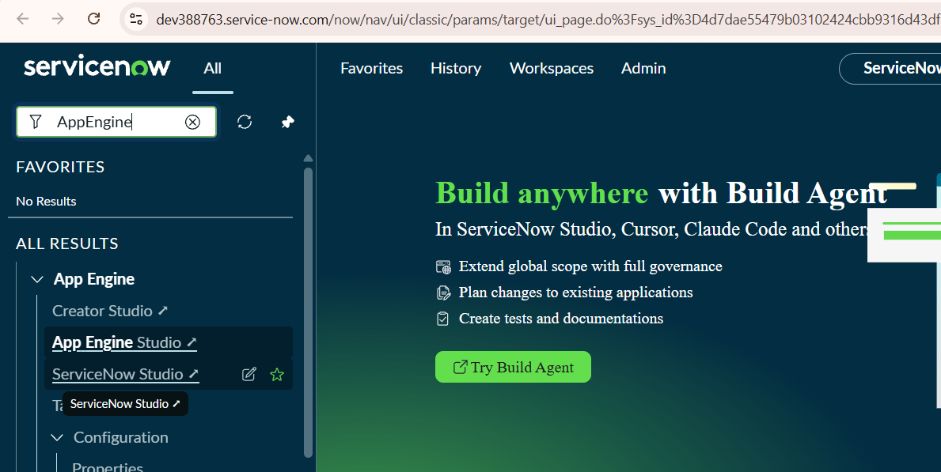
Figure 1 : Starting with all the installations and developer instance.
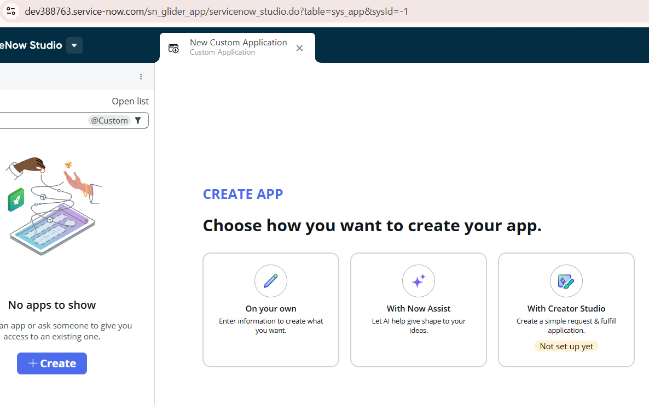
Figure 2: Creating a scoped application
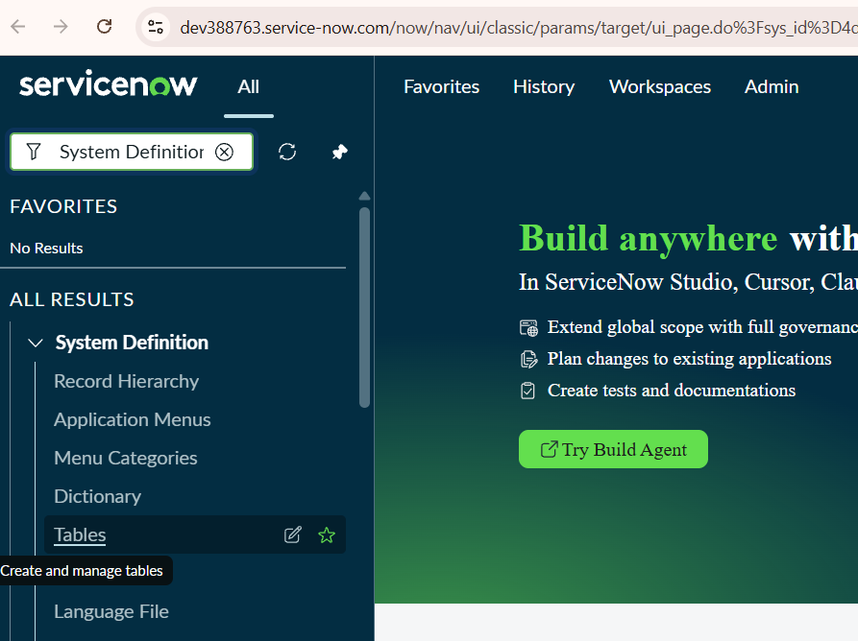
Figure 3: Creating a table that stores the tasks by service catalog.
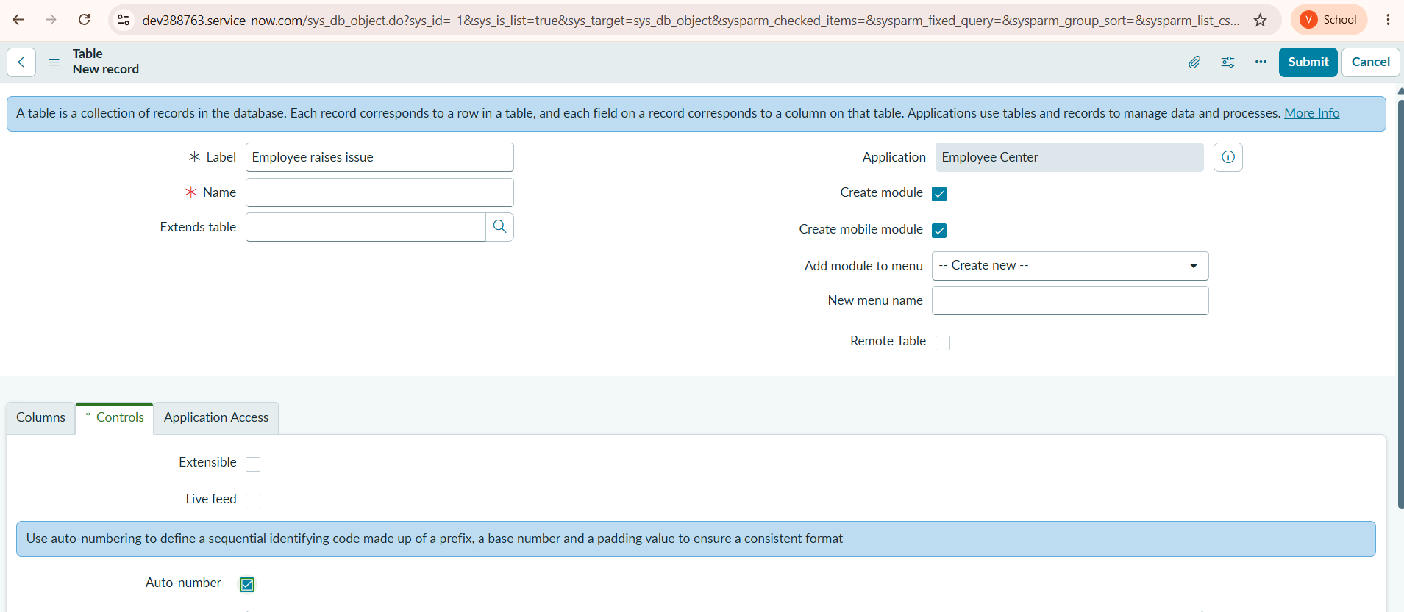
Figure 4: Configuartion of table name, label and controllers.
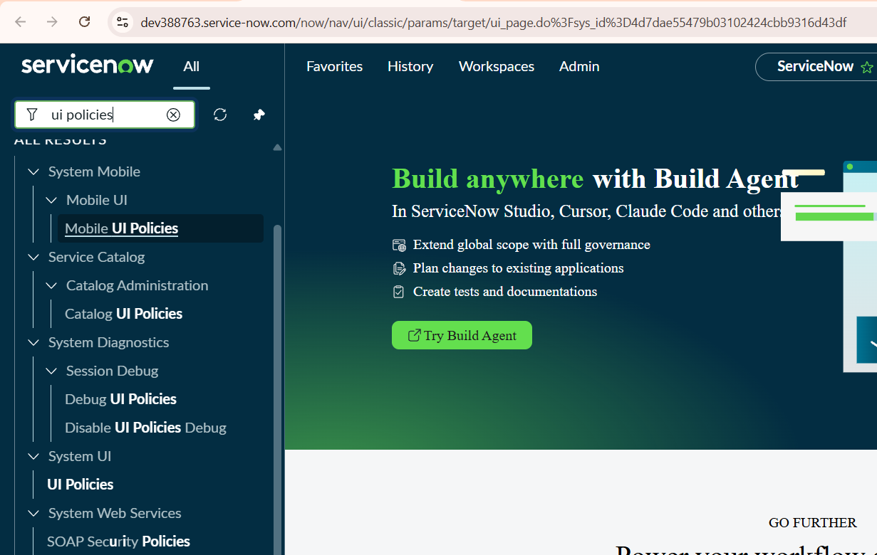
Figure 5 : Setting the UI Policies.
Figure 6: Creation of the ui policies
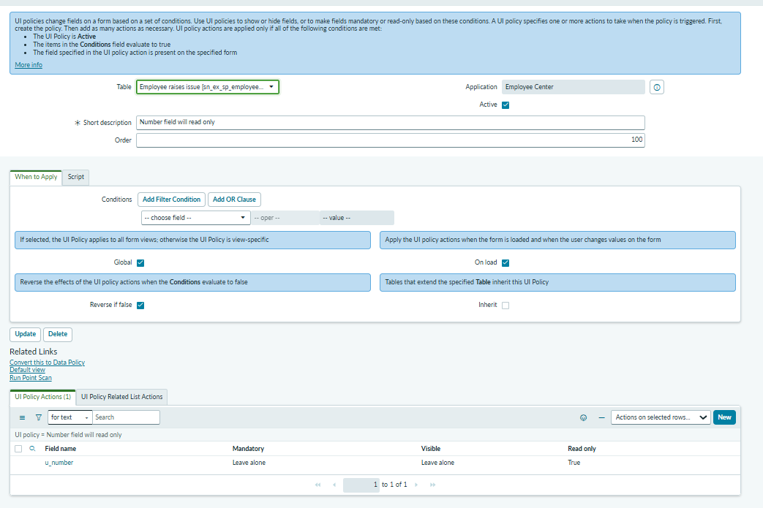
Figure 7 : Setting UI Policie Actions.

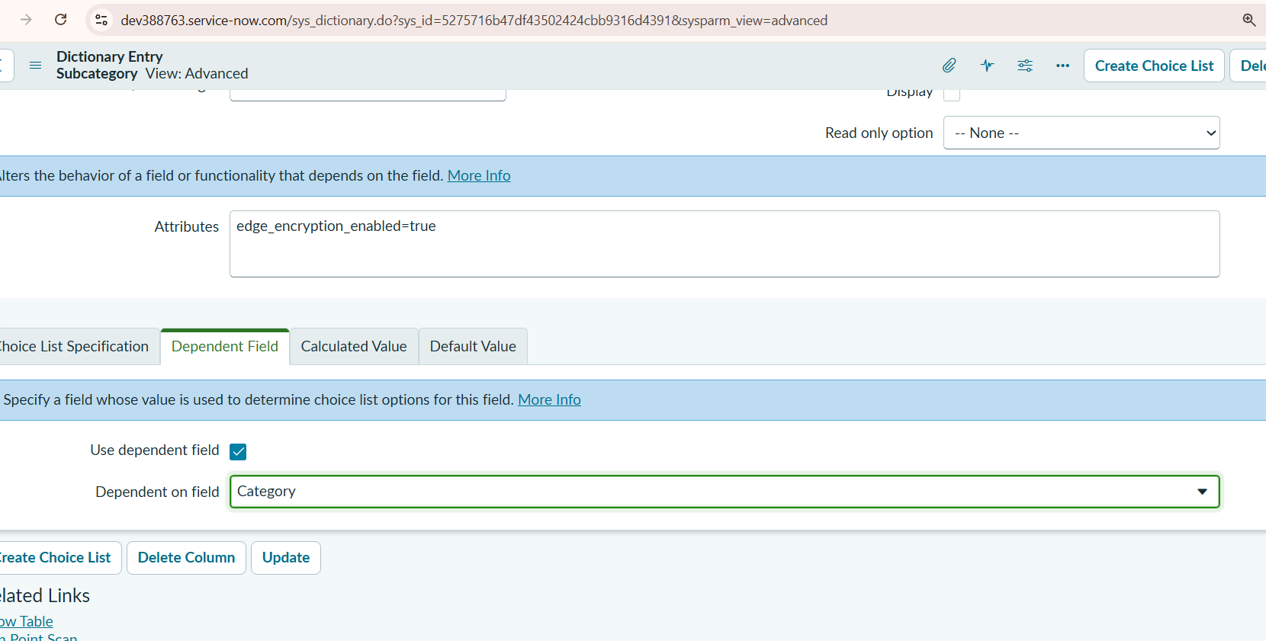
Figure 8 : Setting dependency Field

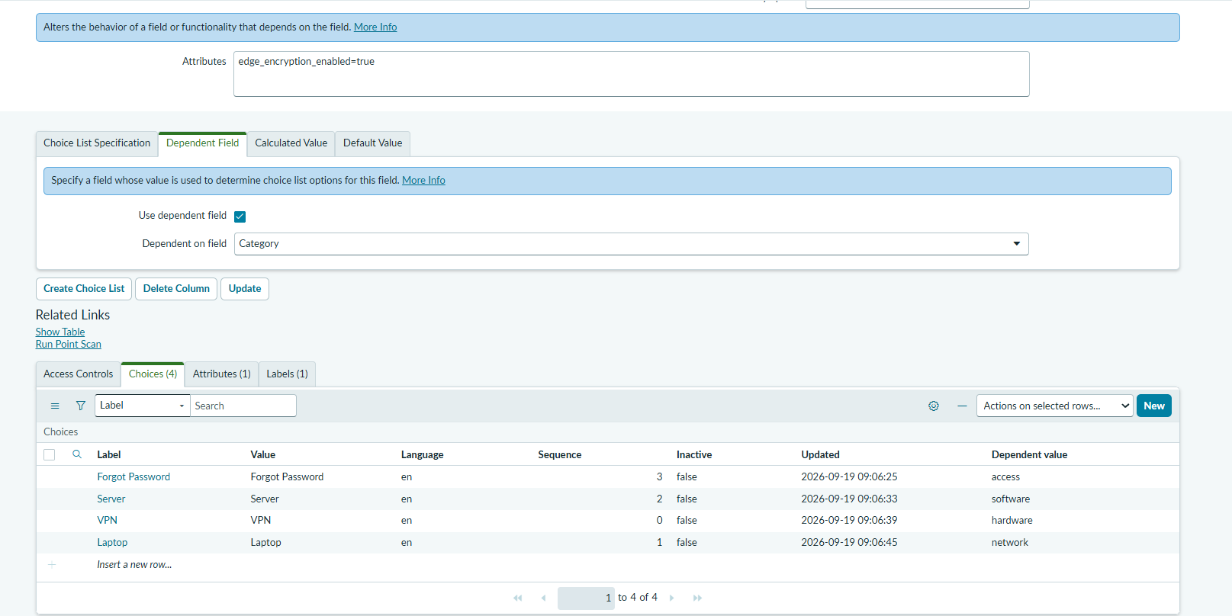
Figure 9 : Creating choices for category
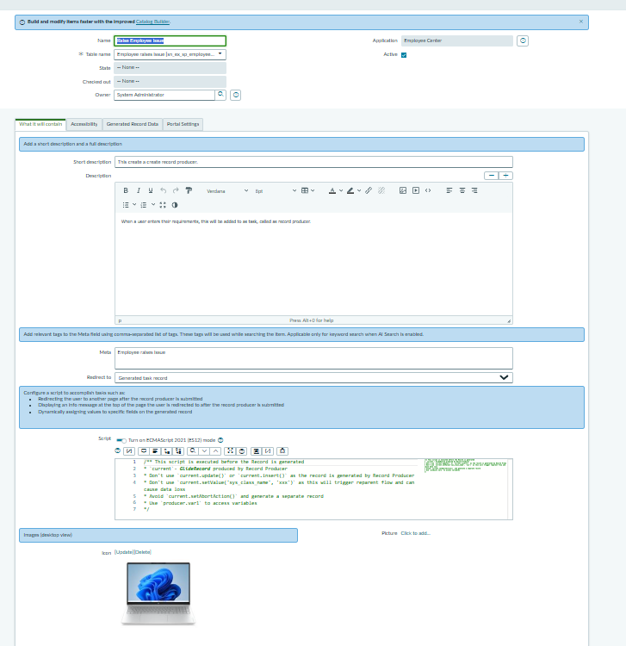
Figure 10 : Creating a service portal page
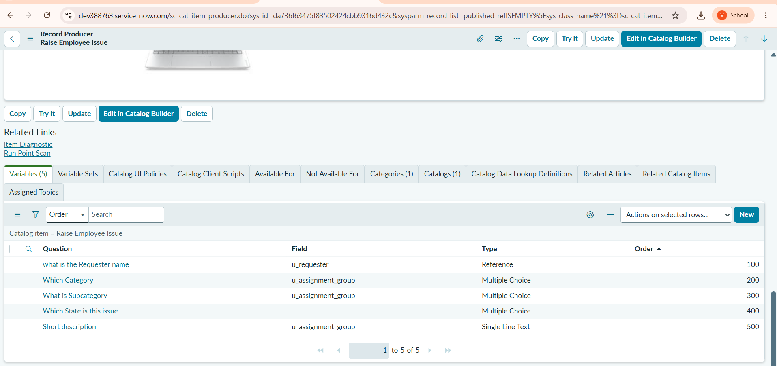
Figure 11 : Creating a variable set
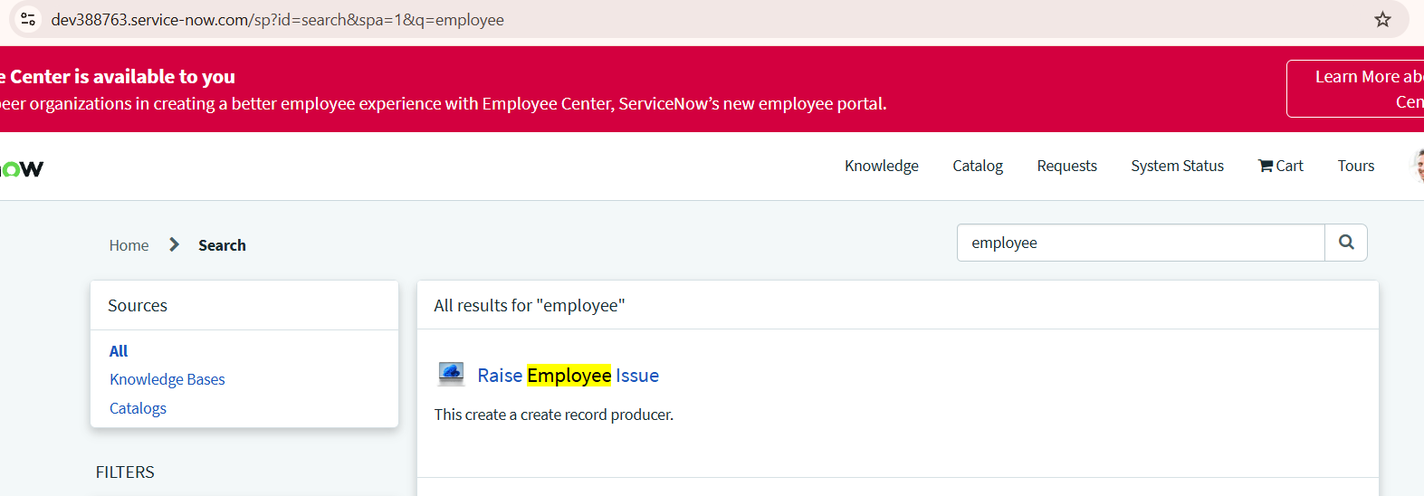
Figure 12 : Verifying record producer

Summary: The demonstrated workflow successfully connects the Service Portal, Record Producer, Employee Issue custom table, validation, business logic, assignment, prioritization, and issue status tracking. The implementation provides evidence of the employee issue submission form, successful creation of the Employee Issue record, configured validations and field dependencies, server-side processing, assignment and priority handling, and status updates throughout the issue lifecycle.

Advantages | Disadvantages / Limitations
Standardizes the collection of employee issue information through the Record Producer. | The current implementation depends on the configured ServiceNow tables, scripts, policies, and business rules.
Provides a simple employee-facing issue submission experience through the Service Portal. | Advanced automation such as complex workflows, approvals, and escalations may require additional configuration.
Centralizes employee issues in a dedicated custom table for easier management and tracking. | Quantitative performance benchmarking was not captured as part of the demonstrated implementation.
Client-side and server-side validation helps improve data consistency and reduce invalid submissions. | The demonstrated solution focuses primarily on the core employee issue-management use case.
Field dependencies and UI Policies provide dynamic and controlled form behavior. | Additional configuration may be required to support organization-specific departments, assignment groups, and issue categories.
Business Rules can support consistent processing, assignment, and prioritization of issues. | Actual automated assignment and prioritization depends on the business rules configured in the ServiceNow instance.
Provides visibility into issue status and resolution progress. | Advanced SLA monitoring, escalation, and reporting capabilities are not part of the core implementation.
Reduces dependence on informal email-based issue reporting and manual coordination. | Integration with external HR, identity, asset-management, or enterprise systems may require additional development.
The solution can be extended with notifications, workflows, SLAs, dashboards, and reports. | The solution is dependent on the availability and configuration of the ServiceNow platform and its relevant modules.
Provides a reusable foundation for broader employee service-management processes. | Large-scale enterprise deployment would require additional security, access-control, testing, and governance configuration.

9. CONCLUSION

The ServiceNow Employee Issue Management project demonstrates how ServiceNow can be used to structure and manage the lifecycle of workplace-related employee issues. The implementation provides a Service Portal entry point through which employees can raise issues using a Record Producer, captures standardized issue information, creates records in a dedicated Employee Issue custom table, and applies configured validations, field dependencies, and business logic.

The implemented solution provides a structured process for issue submission, validation, categorization, assignment, prioritization, and status tracking. The use of Client Scripts, UI Policies, Data Policies, Business Rules, and Service Portal components demonstrates how different ServiceNow capabilities can work together to provide a consistent employee-facing issue-management experience.

The project therefore establishes a reusable foundation for a more comprehensive employee service-management solution. It can be further extended with automated workflows, notifications, SLAs, dashboards, approvals, escalation rules, knowledge-base integration, and additional employee-service capabilities.

10. FUTURE SCOPE

● Integrate the Employee Issue Management application with Flow Designer / Workflow Studio to automate issue routing, notifications, approvals, and additional processing steps.

● Introduce dynamic assignment rules based on issue category, department, location, priority, or type of employee issue.

● Add Service Level Agreements (SLAs) and escalation rules to ensure issues are addressed within defined resolution timelines.

● Provide dashboards and reports for issue volume, categories, priorities, assignment groups, resolution time, and open/closed issue trends.

● Add automated email or ServiceNow notifications for issue submission, assignment, status changes, resolution, and closure.

● Introduce approval workflows for issue categories that require manager, HR, IT, or other organizational approval.

● Extend the application with knowledge-base integration, allowing employees or support teams to access relevant solutions for commonly reported issues.

● Integrate with employee, department, location, and organizational data to improve issue validation and automatically determine the appropriate assignment group.

● Add SLA-based prioritization and escalation so high-priority or overdue employee issues can be automatically escalated to the appropriate support team.

● Implement employee feedback and satisfaction tracking after issue resolution to measure the quality of the support experience.

● Extend the solution with ServiceNow Virtual Agent capabilities so employees can raise and track issues through conversational interactions.

● Integrate with other enterprise service-management applications to provide a more comprehensive employee service and issue-resolution ecosystem.

11. APPENDIX

Project Demo Link: https://drive.google.com/file/d/1OONOwkvkoUupqb6f4ekyeX-qL07n9B9W/view?usp=sharing

